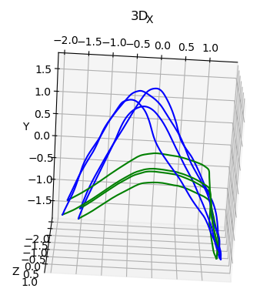
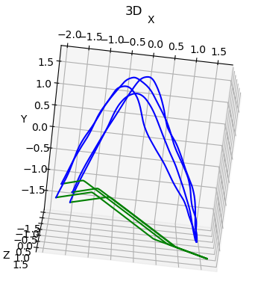
------epoch:1--------
The mean Error is: 2.2264097513037533
The Frechet Distance is: 2.470408888576995
The DTW Distance is: 1773.736248631121
The Swept Area error is: 3.536403117316002
The Area error is: 3.9159431750044944
##########################
Validation data Log Likelihood: 3.5213310718536377
log pz : 7.344412326812744
log detJ : -3.8230814933776855
------epoch:21--------
The mean Error is: 1.485409275904564
The Frechet Distance is: 2.6649053836745757
The DTW Distance is: 794.9740281251101
The Swept Area error is: 0.5906396587246823
The Area error is: 1.4893877364465693
##########################
Validation data Log Likelihood: 7.880081653594971 | log pz : 5.806794166564941 | log detJ : 2.07328724861145
------epoch:21--------
The mean Error is: 2.0535298577105547
The Frechet Distance is: 3.1586349589315175
The DTW Distance is: 2036.09379532111
The Swept Area error is: 5.812644426400061
The Area error is: 5.812644088818035
##########################
Validation data Log Likelihood: 4.697565078735352 | log pz : 5.0127272605896 | log detJ : -0.3151624798774719
With normal coupling layer
With ResNetcoupling layer

--------epoch:1--------
The mean Error is: 1.529676939036357
The Frechet Distance is: 2.4766031491737808
The DTW Distance is: 1432.0313599665928
The Swept Area error is: 4.565043372525434
The Area error is: 4.565043630536849
##########################
Validation data Log Likelihood: 3.5913352966308594 | log pz : 6.024532318115234 | log detJ : -2.433197021484375

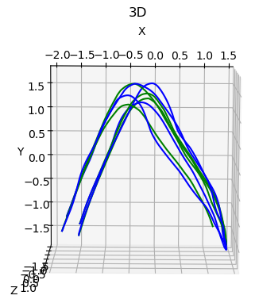

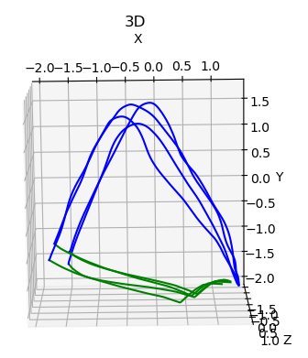

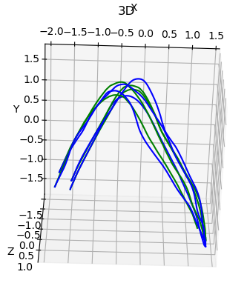
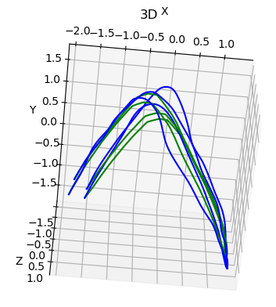

------epoch:41--------
The mean Error is: 1.4687435267414592
The Frechet Distance is: 2.674632447226676
The DTW Distance is: 795.008220205249
The Swept Area error is: 0.6602924003325988
The Area error is: 1.5234273528443205
##########################
Validation data Log Likelihood: 8.135419845581055 | log pz : 5.600593566894531 | log detJ : 2.5348260402679443
------epoch:41--------
The mean Error is: 1.161619135947028
The Frechet Distance is: 1.9896728943786188
The DTW Distance is: 596.211329893938
The Swept Area error is: 0.7274435485534891
The Area error is: 1.1409673250455856
##########################
Validation data Log Likelihood: 5.604004383087158 | log pz : 4.781072616577148 | log detJ : 0.8229320645332336

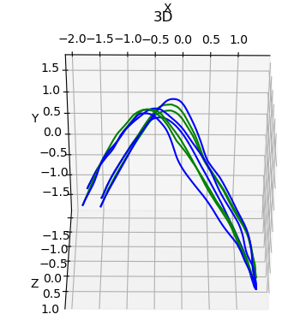
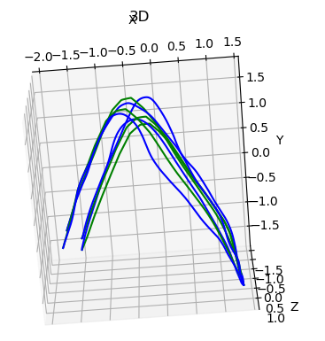

------epoch:61--------
The mean Error is: 1.0950288158580588
The Frechet Distance is: 1.776188392023982
The DTW Distance is: 493.6951119047178
The Swept Area error is: 0.5761772041489797
The Area error is: 0.9630850652993561
##########################
Validation data Log Likelihood: 5.806979179382324 | log pz : 4.717144966125488 | log detJ : 1.0898343324661255
------epoch:61--------
The mean Error is: 1.5175597337688838
The Frechet Distance is: 2.693486913899301
The DTW Distance is: 813.0267377415705
The Swept Area error is: 0.7301542099042522
The Area error is: 1.5806195935956415
##########################
Validation data Log Likelihood: 8.255528450012207 | log pz : 5.49398136138916 | log detJ : 2.761547327041626

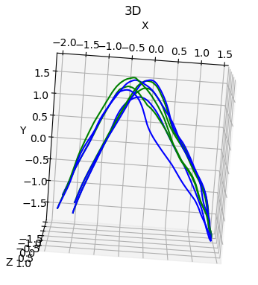

------epoch:121--------
The mean Error is: 1.4005091579403297
The Frechet Distance is: 2.4069251094469637
The DTW Distance is: 716.9046537118576
The Swept Area error is: 0.7083437545629947
The Area error is: 1.4030073914989896
##########################
Validation data Log Likelihood: 9.011425018310547 | log pz : 5.860969543457031 | log detJ : 3.1504557132720947

5s for 1 epoch
15-20s for generating one trajectory

